BID SPECIFICATIONS FOR

J Wing Stairway Repairs at Nevada Union High School

FOR: NEVADA JOINT UNION HIGH SCHOOL DISTRICT
11645 RIDGE ROAD
GRASS VALLEY, CA 95945

Bid Specification Date:
5/20/2021

Job Walk:
May 26th, 2021 at 1:00pm
Nevada Union High School
11761 Ridge RD., Grass Valley, CA 95945

BID DUE DATE:

June 4th, 2021 at 2:00pm

Estimated Cost $65,000

NOTICE INVITING BIDS

Notice is hereby given that the Board of Trustees of the Nevada Joint Union High School District, herein known as Owner, will receive bids from qualified, registered CUPCCAA contractors. Bids will be received up to but not later than, June 4th at 2:00 p.m. at the District Office, 11645 Ridge Road, Grass Valley, CA 95945 for the following:

J Wing Stairway Repairs at Nevada Union High School
11761 Ridge Rd
Grass Valley, CA 95945

Each bid must conform to the requirements of the Specifications and other documents comprising the Contract Documents, all of which may be examined at www.njuhsd.com

To submit a bid on this project, all prime bidders should attend a Project Walk-thru and briefing on May 26th, 2021 at 1:00pm at Nevada Union High School, Grass Valley CA 95945. Meet at the job site (across Ali Ave from the wrestling gym).

Nevada Joint Union High School District reserves the right to reject any and/or all bids, to be the sole judge of the suitability of bids offered and to waive any irregularities.

NEVADA JOINT UNION HIGH SCHOOL DISTRICT

BIDDER’S CHECKLIST FOR:

J Wing Stairway Repairs at Nevada Union High School
Grass Valley, CA 95945

BID DUE: June 4th, 2021 by 2:00pm

This form is the first page when you submit your bid package. Attach items required below in the same order as listed below
ITEMS REQUIRED  WITH BID | APPLICABLE  TO THIS BID | COMPLETED (For Bidder’s Use)
Bid Form | [ x ] | [ ]
Materials List With Specifications and Product Brochures | [ ] | [ ]
Proposed alternate products. | [ X ] | [ ]
Sub Contractor List (if .5% or more) | [ X ] | [ ]
Pre Qualification | [ ] | [ ]
Non-collusion Affidavit | [ x ] | [ ]
Workers’ Compensation Insurance Certificate | [ x ] | [ ]
Prohibitions About Tobacco Products | [ x ] | [ ]
Drug-Free Workplace Certification | [ x ] | [ ]
Bond of Faithful Performance (Bid Bond)  (Guarantee in the amount of 10% of the bid submitted for all projects over $25,000.) | [ x ] | [ ]
DVBE - Good faith | [ X ] | [ ]

NOTE: Items checked under the “Applicable To This Bid” column indicate items that are required with this bid. Please read the attached specifications carefully to make certain you submit all of the required documents.
INSTRUCTIONS TO BIDDERS

The Project
The work to be done consists of providing all labor, supervision, materials, and equipment needed to complete the project as described in the attached contract documents.

SCOPE OF WORK

Per attached specifications and drawings

AREAS OF WORK

Nevada Union High School, Grass Valley CA 95945

Bid Documents and Process

- This Job requires all General contractors to be registered with the district's CUPCCAA list to receive notification to bid.
- All bids must be submitted in writing on the Bid Form provided and no later than 2:00 pm on June 4th, 2021. NJUHSD encourages and will accept electronic bid submittals in a PDF form for all projects.
Submit all bids To: jkohler@njuhsd.com and hquiggle@njuhsd.com You will receive an acknowledgment of receipt. If you do not, you are responsible to contact hquiggle@njuhsd.com Bids will be opened approximately 3 minutes after the advertised opening time to allow for electronic transmission and receipt acknowledgement by The District. Bid openings will take place via Google meets or Zoom. The link to this event will be posted on the district website at the location of other published materials related to the project: https://www.njuhsd.com/Measure-B--/Upcoming-Projects-to-Bid/index.html
Bid results will be posted at the same location.

Paper Bid packages must be addressed and delivered to:

Jordan Kohler,
Director of Facilities and Construction
Nevada Joint Union High School District
11645 Ridge Road
Grass Valley, CA 95945

- In order to preserve uniformity and to facilitate the award of contracts, no bids will be considered unless made upon the forms furnished by the District.

- The Nevada Joint Union High School District reserves the right to reject any and all bids or waive any irregularity or non conformance of any bid.

- No contract awarded under this proposal shall be signed, except with the approval of the Nevada Joint Union High School District.

- The bidder’s proposal and any contract entered into are subject to all applicable statutes of the United States or of the State of California and all applicable regulations and orders of the Federal and State governments now in effect or which shall be in effect during the period of such contract.

- All prices or notations must be typewritten or written in ink. Bids written in pencil will not be accepted. Verify all quotations before submission, as they cannot be corrected after the proposals are opened.

- In accordance with the provisions of Sections 1770 and 1773 of the Labor Code, the Director of Industrial Relations has determined the general prevailing rate of wages applicable to the work to be done. These rates are set forth in a schedule located at the State Department of Industrial, Director of Industrial Relations, (415) 557-3356; said schedule is available to any interested party on request. The contractor shall post a copy thereof at each job site.

Attention is directed to the provisions of Section 1777.5 and 1777.6 of the Labor Code of the State of California concerning employment of apprentices by the contractor or any subcontractor under him. The prime contractor is responsible for compliance with the requirements of Section 1777.5 and the prime contractor and any subcontractor under him shall comply with the requirements of Section 1777.6.

- Proposals may be withdrawn by the bidder prior to but not after the time fixed for opening of proposals.

- Pursuant to the provisions of Section 4100 to 4108, inclusive of the Government Code of the State of California, every bidder shall in this bid set forth:

1. The name and location of the place of business of each subcontractor who will perform work or labor or render service to the bidder in or about the work in an amount in excess of one-half (1/2) of one percent (1%) of the bidder’s total bid.

2. The portion of the work that will be done by each sub-contractor. If the bidder fails to specify a subcontractor for any portion of the work to be performed under the contract in excess of one-half (1/2) of one percent (1%) of the bidder’s total bid, he agrees to perform that portion himself. The successful bidder shall not, without the consent of the Owner, either

a. substitute any person as subcontractor in place of the subcontractor designated in the original bid;

b. permit any subcontract to be assigned or transferred or allow it to be performed by anyone other than the original subcontractor listed in the bid;

c. sublet or subcontract any portion of the work in excess of one-half (1/2) of one percent (1%) of the total bid as to which his original bid did not designate a subcontractor.

- A bid guarantee in the amount of ten percent (10%) of the bid must accompany the bid. Failure to furnish a required bid guarantee in the proper form and amount, by the time set for opening the bids, may be cause for rejection of the bids. A bid guarantee shall be in the form of a firm commitment, such as a bid bond, personal money order, certified check, or cashier’s check. Bid guarantee will be returned to unsuccessful bidders as soon as practicable after the opening of the bid. If the successful bidder fails to enter into the contract and give bond within the time specified after the forms are presented to him, he shall be liable for any differences by which the cost of securing the supplies and services exceeds the amount of bid and the bid guarantee shall be available toward offsetting such difference.

- Proposals will be opened and read at or about the time set in the advertised NOTICE TO BIDDERS. Bidders, or their representatives, and other interested persons may be present at the opening of the proposals. At the district's discretion this may be performed using an electronic platform.

- Bid disputes and all disputes must be written and received by the district no more than 48hrs after bid opening, only one dispute is allowed per responsible bidder. The district superintendent is the final authority for dispute resolutions.

Contract

The form of contract that the successful bidder will be required to execute, if awarded the work, is attached herein and is made a part thereof.

Site Visit

Bidders should attend a Project Walk-thru and briefing on May 26th , 2021 at 1pm at Nevada Union High School, Grass Valley CA. The Walk trough will be hosted by a representative of NJUHSD.

REGULATIONS, PERMITS AND LICENSES

- The Contractor shall obtain all permits and all licenses that are required for the performing of his work by all laws, ordinances, rules, regulations, or orders of any officer and/or body lawfully empowered to make or issue the same and having jurisdiction, and shall give all notices necessary in connection therewith, and pay all fees relating thereof, and deliver certificates of same to the Owner, except when otherwise provided herein.

- The Contractor shall conform to all Federal, State and local laws, ordinances and regulations covering this work.

GENERAL CONDITIONS

EXECUTION OF CONTRACT

- The Contractor to whom the work is awarded shall, within five (5) days after being notified of such award, enter into a contract with the Owner for the work, in accordance with the Drawings and Specifications. Simultaneously with the execution of the Contract, the Contractor shall furnish a Labor and Material Bond in an amount not less than fifty percent (50%) of the contract price; and a faithful performance bond in an amount equal to one hundred percent (100%) of the contract price; said bonds shall be secured by a surety company satisfactory to the Owner.

COMPENSATION AND PUBLIC LIABILITY

- The Contractor shall maintain such insurance as will protect him from claims under Workers’ Compensation Acts, and Public Liability Insurance in an amount not less than $250,000 for injuries, including wrongful death, to any one person, and subject to the same limit for each person, in an amount not less than $500,000 on account of one accident, and Property Damage Insurance in an amount not less than $100,000, whether such operations be by himself of by any subcontractor or anyone directly or indirectly employed by either of them, and shall include the owner as additional named insured. Certificates of such Workers’ Compensation and Public Liability Insurance shall be filed with the Owner and shall be subject to his approval of adequacy of protection.

- The Contractor shall require all subcontractors engaged by him on the work to maintain adequate insurance to protect such subcontractors from claims under Workers’ Compensation Acts.

INDEMNIFICATION

- The Contractor shall indemnify and hold harmless the Owner and its agents and employees from and against all claims, damages, losses and expenses, including attorneys’ fees, arising out of or resulting from the performance of the work, provided that any such claim, damage, loss, or expense (a) is attributable to bodily injury, sickness, disease or death, or to injury to or destruction of tangible property (other than the work itself) including the loss of use resulting therefrom, and (b) is caused in whole or in part by any negligent act or omission of the Contractor, any subcontractor, anyone directly or indirectly employed by any of them, or anyone for whose acts any of them may be liable, regardless of whether or not it is caused in part by a party indemnified hereunder.

- In any and all claims against the Owner or any of its agents or employees by any employee of the Contractor, any subcontractor, anyone directly or indirectly employed by any of them or anyone for whose acts any of them may be liable, the indemnification obligation shall not be limited in any way by any limitation on the amount or type of damages, compensation or benefits payable by or for the Contractor or any subcontractor under Workers’ Compensation Acts, Disability Benefit Acts or other employee benefit acts.

TIME OF WORK

- The Contractor shall have the work completed no later than August 11, 2021.

- The Contractor obligates himself to make the whole work complete and satisfactory on or before such date as shall be determined by the elapsed number of calendar days set forth in the proposal, plus any extension approved by the Owner.

DELAYS
- The time during which the Contractor is delayed in said work by the unavailability of needed labor or materials, when the fact of such unavailability is established to the satisfaction of the Owner, or by the actions or neglect of the Owner or his employees or those under him by contract or otherwise, or by stormy and inclement weather that delayed the work, or by any strikes or like trouble among mechanics or laborers that delayed the work shall be added to the time for completion hereinafter provided, if such delays are not caused by or the continuation of which is not due to any fault or negligence on the part of the Contractor; but the Owner shall not be liable for any damage on account of any such delay; provided the extension of time for such delays shall be considered by the Owner only when a request for such extension is made in writing by the Contractor, and provided further that any such request shall be presented to the Owner within ten (10) days of the start or close of the period of delay whichever occurs first.

ASSIGNMENT

- The Contractor shall under no circumstances assign this Contract without the written permission of the Owner.

LIQUIDATED DAMAGES

- The number of calendar days required to complete the project is listed in the “Bid Form” and, because actual damages for delay in completion of the work cannot be determined, the amount, if any, that may be assessed as liquidated damages for each day’s delay beyond the scheduled completion date is also stated on the Bid Form.

GUARANTEE

- Besides any guarantees required elsewhere, the contractor shall guarantee the work for five (5) years. All special guarantees required by these Specifications shall be in writing and in the form required, and delivered to the Owner before the final payment is made.

PAYMENTS

- Upon acceptance by the Owner of the work to be performed, and after being presented with a proper payment request, the Owner will pay ninety percent (90%) of the contract amount to the Contractor (within 20 working days). The final payment of ten percent (10%), if unencumbered, or any part thereof unencumbered, shall be made no sooner than thirty-five (35) days after acceptance of the work by the Owner. Pursuant to California Public Contract Code 22300, the successful bidder may substitute securities for any money withheld.

CHANGE ORDER

- No change will be made unless approved in writing by the owner before work, costs or additional time is incurred. A written Change Order form, will be presented for the Owners consideration by the prime contractor, stating that the extra work or change is authorized, and no claim for an addition to the contract sum shall be valid unless the extra work or change is so ordered and approved. This form will be inclusive of all trades,subcontractors and material costs for the entire proposed scope.

- The Owner at any time during the progress of the work shall have the right to order alterations in, additions to, or deviations or omissions from the work contemplated by this Contract, and the same shall in no way make void the Contract. If any such changes involve an increase or decrease in the Contract amount, the Change Order shall state the amount to be added to or deducted from the Contract amount and shall also state the additional time, if any, needed for the performance of the work, provided that an addition to or deduction from the Contract amount shall be determined upon the basis of an estimate and acceptance of a lump sum; and provided further that, where additions to the Contract amount cannot feasibly be determined upon such estimate and acceptance basis, such additions shall be upon the basis of actual cost of labor and overhead expense for the extra work.

INSPECTION

- All materials furnished and work done under these specifications shall be subject to rigid inspection by the Owner. If the Specifications, laws, ordinances or other public authority require any work to be specifically tested or approved, the Contractor shall give the timely notice of this readiness for inspection, and if the inspection is by another authority other than the Owner, of the date fixed for such inspection. Work done in the absence of prescribed inspection may be required to be torn out and replaced under the proper inspection, and the entire cost of tearing out and replacement, including the cost of all materials furnished by the Owner and used in the work torn out, shall be borne by the Contractor irrespective of whether the work torn out is found to be defective or not. Work covered up without the authority of the Owner shall be uncovered to the extent required and the Contractor shall similarly bear the entire cost of performing all the work and furnishing all the material necessary for the removal of the covering and its subsequent replacement.

- Whenever the Contractor arranges to work at night, or at any time when work is not usually in progress, or to vary the period during which work is carried on each day, he shall give the Nevada Joint Union High School District due notice so that inspection may be provided. Such work shall be done without extra compensation to the Contractor.

MATERIALS, SAMPLES AND TESTS

- The Contractor shall furnish and use new materials of the quality required by the provisions of the Contract for every part of his work, unless otherwise specified.

- Substitutions

- Should the bidder wish to request prior to bid opening, any substitution for the specified materials, process, service or equipment, the bidder shall submit a written request at least ten (10) working days before the bid opening date and hour. If the requested substitution is acceptable, the DISTRICT will approve it in an Addendum issued to all bidders of record. Requests received less than ten (10) working days prior to bid opening will not be considered. Extensions of the bid date shall not operate to extend the deadline for requesting substitutions unless the DISTRICT so states in an addendum issued to all bidders of record.

- With respect to any materials, process, service, or equipment listed in the bid, unless the bidder clearly indicates in its bid that it is proposing to use an “equal” material, process, service or equipment, its bid shall be considered as offering the specified matter, process, service or equipment referred to by the brand name or trade name specified.

- If not requested and considered prior to the bid date, the brand name or trade name, if any, of a proposed substitute item shall be inserted in the space provided in the bid or shall be otherwise clearly identified in the bid. It is expressly understood and agreed by the bidder that the DISTRICT reserves the right to reject any such proposed substituted item. It is further expressly understood and agreed by bidder that in the event the DISTRICT rejects a proposed “equal” item, the bidder will then supply the specified material, process, service or equipment designated by brand name or trade name.

- No substitutions of “equal” materials, process, service or equipment may be made after the bid date, except by the express written permission of the DISTRICT and on such terms as DISTRICT may require. These time limitations shall be complied with strictly, and in no case will an extension of time for completion be granted because of the bidder’s failure to request the substitution of an item at the times and in the manner set forth herein.

- With respect to all proposed substitutions, the bidder shall submit all pertinent and appropriate data substantiating its request for substitutions with its bid. The DISTRICT is not responsible for locating or securing any information which is not included in such substantiating data. The burden of proof as to the quality or suitability of proposed substituted items shall by borne by the bidder. The DISTRICT shall be the sole judge as to the quality and suitability of proposed substituted items, and decisions of the DISTRICT shall be final and conclusive. DISTRICT shall notify the bidder of the decision concerning the proposed substitution of “equal” items prior to contract award. All such decisions by the DISTRICT shall be in writing, and no proposed substituted item shall be deemed approved unless the DISTRICT has so indicated in writing.

  - CONTRACTOR shall follow all instructions and requirements set forth in the Instructions To Bidders for substitutions of “equals”. Per section 3400 of the Public Contract Code, the DISTRICT desires all “or equal” substitutions to be resolved prior to award of contract.

  - As to any other substitution request, CONTRACTOR shall timely submit such requests, together with substantiating data, including substitution warranties, in order to prevent delays arising there from.

  - With respect to all proposed substitutions:

a. Every substitution request must be on the Substitution Request form designated by DISTRICT, if any, accompanied by evidence as to whether or not the proposed substitutions,Is equal in quality and serviceability to the specified item;

    - Will entail no changes in detail and construction of related work;

    - Will be acceptable in consideration of the required design and artistic effect;

    - Has no significant adverse impact on the contemplated or existing construction schedule or on the completion date;

    - Will provide no cost disadvantage to DISTRICT; and Will require no excessive or more expensive maintenance, including adequacy and availability of replacement parts within the County.

- The Contractor shall furnish with its request all drawings, specifications, samples, performance data, calculations, and other information as may be required to assist the Architect and the Owner in determining whether the proposed substitution is acceptable.

- The DISTRICT is not responsible for locating or securing any information which is not included in such substantiating data.

- The substitution proposed by CONTRACTOR must be, in the opinion of the DISTRICT, substantially equal or better in every aspect. The burden of proof as to the quality or suitability of proposed substituted items shall be borne by the bidder.

- The DISTRICT shall be the sole judge as to the quality and suitability of proposed substituted items, and decisions of the DISTRICT shall be final and conclusive.

- All substitutions shall be submitted with a Substitution Warranty. Any substitution requests submitted without the warranty will not be considered, but will be returned to the CONTRACTOR WITHOUT REVIEW OR EVALUATION. If required by the DISTRICT, the CONTRACTOR shall provide an extended warranty for the requested substitution.

- No extension of time shall be granted if the extension request arises from a request for substitution, whether by reason of delay in making the request, delay in DISTRICT’S approval of the request, delay in obtaining other governmental approvals, delay in coordination of substitutions into or with other work or equipment, delay in obtaining the substituted items, increased time of installation or performance, or for any other reason.

- Once any part of all of a Substitution Request has been denied it is considered always denied.

- A substitution request shall be submitted separately from any other submittal and shall be clearly marked as a “Request for Substitution.”

- If the substitution is accepted, the CONTRACTOR shall bear all costs and be solely and directly responsible for fitting accepted substitute materials and equipment into the available space in a manner acceptable to the ARCHITECT and DISTRICT, and for the proper operation of the substituted equipment with other equipment with which it may be associated.

- Any additional time, coordination, inspection, materials, equipment, lab, tools, warranty extension or other items necessary to accomplish a substitution will be the sole responsibility and at the sole expense of the CONTRACTOR.

- The CONTRACTOR shall also be responsible for meeting all code requirements whether local, City, County, State, Federal, or other.

  - If the substitution requested by CONTRACTOR is not, in the opinion of the DISTRICT, substantially equal or better in every respect to that specified, then CONTRACTOR shall perform as specified.

  - In the event CONTRACTOR furnishes a material, process, service, or equipment more expensive than that specified, the difference in cost of such material, process, service, or equipment so furnished shall be borne by CONTRACTOR. Any difference in cost between an approved substitution which is lower in cost than the originally specified item shall be refunded by CONTRACTOR to DISTRICT.

  - Any engineering, design fees, or approval agencies’ fees required to make adjustments in material or work off all trades directly or indirectly affected by the approved substitution shall be borne entirely by CONTRACTOR.

- If after the OWNER or his AGENT has made an approval of material or equipment, it is found that the materials or equipment presented and approved for use are not justifiably equal in quality and performance to the product originally specified, the Owner or his Agent retains the right to revoke said approval and reject the materials or equipment prior to installation without any additional cost.

- All materials, samples, tests, and inspections shall be in accordance with the requirements of the specifications.

BID FORM

Bids will be received until 2:00 pm on June 4th, 2021 at the Office of the District Superintendent of the Nevada Joint Union High School District, 11645 Ridge Road, Grass Valley, CA 95945.

TO: Board of Trustees
Nevada Joint Union High School District

Trustees:

Having examined the specifications and any addendas issued by the Nevada Joint Union High School District Board of Trustees and last dated ______________. Having familiarized ourselves with the job conditions, the undersigned does hereby tender the following bid for the furnishing of all labor and material necessary for:

J Wing Stairway Repairs at Nevada Union High School
Grass Valley, CA 95945

______________________________________________________ DOLLARS
(includes labor, materials, taxes)

($____________________)

The undersigned agrees that should the work not be completed within the time herein stated from and after the date the Contractor is instructed to proceed by the Owner, an amount equal to FIVE HUNDRED DOLLARS ($500.00) per day for each day’s delay after the expiration of such period shall be deducted from the contract sum.

The undersigned has examined the locations of the proposed work and is familiar with the plans and bid specifications and the local conditions of the place where the work is to be done.

The undersigned has checked carefully all the above figures and understands that the Board of Trustees of the Nevada Joint Union High School District will not be responsible for any errors or omissions on the part of the undersigned in making up this bid.

The undersigned acknowledges that the Board of Trustees of the Nevada Joint Union High School District reserves the right to reject any or all bids and/or waive any irregularities or informalities in the bidding.

Enclosed please find bidder’s bond from a surety company registered with the State of California Insurance Commissioner, or cashier’s check in the amount of ten percent (10%) of the bid, or certified check or cashier’s check #__________ of the

_________________________________________ Bank for $______________.

CONTRACTOR: ________________________________________________

BY: ________________________________________________
(Name) (Title)

LICENSE NO.: ________________________ EXPIRATION DATE_______

DIR REGISTRATION#_____________________ EXPIRATION DATE _________

Company Address: ________________________________________________

Telephone No.: ________________________________________________

Dated this _____________ day of ____________________________, ________.

Receipt of Addenda:

#(s)________________ ______________________ ________________
Acknowledged by: Date

LIST OF SUBCONTRACTORS

PROJECT: J Wing Stairway Repairs at Nevada Union High School

Pursuant to the provisions of Section 4100 to 4114 inclusive, of the Government Code of the State of California, and as set forth in the General Provisions, the above-named Contractor hereby designates below the names and locations of the place of business of each subcontractor.

- Check if none
Work to be Done | Name of Subcontractor | Location of  Place of Business
____________________ | ____________________ | ____________________
____________________ | ____________________ | ____________________
____________________ | ____________________ | ____________________
____________________ | ____________________ | ____________________
____________________ | ____________________ | ____________________
____________________ | ____________________ | ____________________
____________________ | ____________________ | ____________________
____________________ | ____________________ | ____________________
____________________ | ____________________ | ____________________
____________________ | ____________________ | ____________________
____________________ | ____________________ | ____________________
____________________ | ____________________ | ____________________
____________________ | ____________________ | ____________________
____________________ | ____________________ | ____________________

NON-COLLUSION AFFIDAVIT FORM TO BE EXECUTED BY BIDDER
AND SUBMITTED WITH BID

State of California )
) ss.
County of _____________)

_____________________________________________, being first duly sworn, deposes and says that he or she is __________________________________ of _______________________________________________________________, the party making the foregoing bid; that the bid is not made in the interest of, or on behalf of, any undisclosed person, partnership, company, association, organization, or corporation; that the bid is genuine and not collusive or sham; that the bidder has not directly or indirectly induced or solicited any other bidder to put in a false or sham bid, and has not directly or indirectly colluded, conspired, connived, or agreed with any bidder or anyone else to put in a sham bid, or that anyone shall refrain from bidding; that the bidder has not in any manner, directly or indirectly, sought by agreement, communication, or conference with anyone to fix the bid price of the bidder or any other bidder, or to fix any overhead, profit, or cost element of the bid price, or of that of any other bidder, or to secure any advantage against the public body awarding the contract or anyone interested in the proposed contract; that all statements contained in the bid are true, and, further, that the bidder has not, directly or indirectly, submitted his or her bid price or any breakdown thereof, or the contents thereof, or divulged information or data relative thereto, or paid, and will not pay any fee to any corporation, partnership, company association, organization, bid depository, or to any member or agent thereof to effectuate a collusive or sham bid.

I certify (or declare) under penalty of perjury that the foregoing is true and correct.

___________________________________
Signature of Bidder

Subscribed and sworn to before me on this _____ day of __________________, 2020.

_______________________________
Notary Public
AGREEMENT

This Agreement made and entered into this _____ day of _________________, _____ by and between the Nevada Joint Union High School District of Nevada County, first party, sometimes hereinafter called Owner, and second party _______________________________________________ sometimes called the Contractor,

WITNESSETH: That the parties hereto mutually covenanted and agreed and by these present do covenant and agree with each other, as follows:

1. The NOTICE TO BIDDERS, ACCEPTED PROPOSAL, LIST OF SUBCONTRACTORS, INSTRUCTIONS TO BIDDERS, WORKERS’ COMPENSATION INSURANCE CERTIFICATE, GENERAL CONDITIONS, LABOR AND MATERIAL PAYMENT BOND, DVBE CERTIFICATE, DRUG-FREE WORKPLACE CERTIFICATION, PROHIBITIONS ABOUT TOBACCO PRODUCTS and PERFORMANCE BOND are attached to and are a part of this Agreement. The complete Contract also includes the specifications and all modifications and amendments. All Contract Documents are intended to cooperate so that any work called for in one and not mentioned in the other, or vice versa, is to be executed the same as if mentioned in all Contract Documents.

2. The said Contractor agrees to furnish all tools, equipment, apparatus, facilities, transportation, labor, and material, other than material, if any, agreed to be furnished by the District hereunder, necessary to perform and complete, in a good and workmanlike manner, the work of:

J Wing Stairway Repairs at Nevada Union High School

as called for, and in the manner designated in, and in strict conformity with this Agreement, and Specifications adopted by the Nevada Joint Union High School District, which said specifications are entitled respectively:

J Wing Stairway Repairs at Nevada Union High School

and are hereby specifically referred to and made a part of this Agreement with like effect as if fully set forth herein.

3. It is understood and agreed that said tools, equipment, apparatus, facilities, transportation, labor, and materials shall be furnished and said work performed and completed as required in said Specifications under the direction and supervision of, and subject to the approval of, the Owner. The Owner shall have the right to accept or reject materials or workmanship, and to determine when the Contractor has complied with the conditions of the Contract.

4. The Nevada Joint Union High School District agrees to pay, and the Contractor agrees to accept, in full payment for the work above agreed to be done,

_____________________________________________ DOLLARS

($__________________) which sum is to be paid according to the provisions of the General Conditions.

5. The time limit for the completion of said work is August 11, 2021 Should said work not be completed within the time hereinabove stated there shall be deducted from the final payment the sum of FIVE HUNDRED DOLLARS ($500.00) per day as liquidated damages, but not as a penalty, for each day’s delay after the expiration of such period until the final physical completion of the work and its delivery to said Owner.

6. Copies of the prevailing rate per diem wages as determined by the Director of the Department of Industrial Relations in accordance with Labor Code Section 1773 are on file as stated in the Notice to Contractors, and copies are available for inspection at that office to any interested party on request.

7. The Contractor agrees to comply with Labor Code Section 1775 (Payment of Prevailing Wage Rates), Labor Code Section 1776 (Keeping Accurate Payroll Records) and Labor Code Section 1777.5 (Placing the Responsibility for compliance with the statutory Requirements for Apprentice able occupations on the Prime Contractor). The Contractor shall comply with the requirements imposed by California Labor Code Sections 1720 through 1815 regarding public works projects and prevailing wage law.

- In the event of any action or proceeding brought by one party against the other party under this Agreement, the prevailing party shall be entitled to recover for the fees of its attorneys in such action or proceeding in such an amount as the court may judge reasonable.
IN WITNESS WHEREOF, the Nevada Joint Union High School District has caused this Agreement to be subscribed by its duly authorized officer on its behalf, and the said Party of the Second Part has signed this Agreement this day and year first above written.

NEVADA JOINT UNION HIGH SCHOOL DISTRICT
of Nevada County, a Political Subdivision of the
State of California

By_____________________________________________________
Jordan Kohler, NJUHSD Director of Facilities and Construction

_________________________________________, CONTRACTOR

By____________________________________________________

BOND OF FAITHFUL PERFORMANCE

KNOW ALL MEN BY THESE PRESENT, that we ________________________

________________________________________________________________

________________________________________________________________

The Contractor in the Contract hereto annexed, as Principal, and ____________

________________________________________________________________

________________________________________________________________

as Surety, are held firmly bound unto the Nevada Joint Union High School District of Nevada County, a Political Subdivision of the State of California, hereinafter called the “Owner,” in the sum of_________________________________________

_______________________________________ DOLLARS ($_____________)

lawful money of the United States, for which payment, well and truly to be made, we bind ourselves, jointly and severally, firmly by these present.

Signed, Sealed, Dated

__________________________________

The condition of the above obligation is that if said Principal as Contractor in the Contract hereto annexed shall faithfully perform each and all of the conditions of said Contract to be performed by him, and shall furnish all tools, equipment, apparatus, facilities, transportation, labor and material, other than material, if any, agreed to be furnished by the Owner, necessary to perform and complete, and to perform and complete in a good and workmanlike manner, the work of

J Wing Stairway Repairs at Nevada Union High School
Grass Valley, CA 95945

in strict conformity with the terms and conditions set forth in the Contract hereto annexed, then this obligation shall be null and void; otherwise bond shall remain in full force and effect and the said Surety will complete the Contract work under its own supervision, by Contract or otherwise, and pay all costs thereof for the balance due under terms of the Contract, and the said Surety, for value received, hereby stipulates and agrees that no change, extension of time, alteration or addition to the terms of the Contract or to the work to be performed thereunder shall in any way affect its obligation on this bond, and it does hereby waive notice of any such change, extension of time, alteration or addition to the terms of the Contract or to the work.

In the event suit is brought upon this bond by the Nevada Joint Union High School District and judgment is recovered, the Surety shall pay all costs incurred by the Corporation in such suit, including a reasonable attorney’s fee to be fixed by the court.

__________________________________

__________________________________

__________________________________
Contractor

__________________________________

__________________________________

__________________________________
Surety

BOND FOR LABOR AND MATERIAL

KNOW ALL MEN BY THESE PRESENT, that we ________________________

________________________________________________________________

________________________________________________________________

The Contractor in the Contract hereto annexed, as Principal, and ____________

________________________________________________________________

________________________________________________________________

as Surety, are held firmly bound unto the Nevada Joint Union High School District of Nevada County, a Political Subdivision of the State of California, hereinafter called the “Owner,” in the sum of ____________________________

_______________________________________ DOLLARS ($_____________)

lawful money of the United States, for which payment, well and truly to be made, we bind ourselves, jointly and severally, firmly by these present.

Signed, Sealed, Dated

__________________________________

The condition of the above obligation is that if said Principal as Contractor in the Contract hereto annexed, or his or its subcontractor, fails to pay for any materials, provisions, provender or other supplies, or items used in, upon, for or about the performance of the work contracted to be done by said Contractor; namely, to furnish all tools, equipment, apparatus, facilities, transportation, labor and material, other than material, if any, agreed to be furnished by the Owner, necessary to perform and complete in a good and workmanlike manner the work of

J Wing Stairway Repairs at Nevada Union High School
Grass Valley, CA 95945

in strict conformity with the terms and conditions set forth in the Contract hereto annexed, or for any work or labor done thereon of any kind, or amounts due under the Unemployment Insurance Code with respect to work or labor performed by any such claimant, or any amounts required to be deducted, withheld and paid over to the Franchise Tax Board from the wages of employees of the principal or his subcontractor pursuant to Section 18806 of the Revenue and Taxation Code with respect to such work and labor, Surety will pay for same in an amount not exceeding the amount specified in this bond.

In the event a suit is brought upon this bond by the Nevada Joint Union High School District and judgment is recovered, the Surety shall pay all costs incurred by the Corporation in such suit, including a reasonable attorney’s fee to be fixed by the court.

This bond is executed in accordance with the requirements of Section 3247 et seq. of the Civil Code, and is subject to the provisions thereof, and shall ensure to the benefit of any and all persons, companies and corporations entitled to file claims under and by virtue of the provisions of Section 3181 of the Civil Code, or to their assigns; and the said Surety for value received, hereby stipulates and agrees that no change, extension of time, alteration or addition to the terms of the Contract or to the work to be performed hereunder shall in any way affect obligation on this bond, and it does hereby waive notice of any such change, extension of time, alteration or addition to the terms of the Contract or to the work.

__________________________________

__________________________________

__________________________________
Contractor

__________________________________

__________________________________

__________________________________
Surety

WORKERS’ COMPENSATION INSURANCE CERTIFICATE

Reference to Labor Code

A. “Every employer, except the State and all political subdivisions or institutions thereof, shall secure the payment of compensation in one or more of the following ways:

1. By being insured against liability to pay compensation by one or more insurers duly authorized to write compensation insurance in this state.

2. By securing from the Director of Industrial Relations a certificate of consent to self-insure, which may be given upon furnishing proof satisfactory to the Director of Industrial Relations of ability to self-insure and to pay any compensation that may become due to this employee.”

Instructions

A. Per Article 5 (commencing at Section 1860), Chapter 1, Part 7, Division 2 of the Labor Code, the following certificate must be signed and filed with the Nevada Joint Union High School District prior to performing any Contract work.

Contractor’s Certification

I am aware of the provisions of Section 3700 of the Labor Code which require every employer to be insured against liability for Workers’ Compensation or to undertake self-insurance in accordance with the provisions of that code, and I will comply with such provisions before commencing the performance of the work of this Contract.

CONTRACTORS STATE LICENSE NO. CONTRACTOR:

________________________________ __________________________

By________________________

By________________________
Authorized Officers or Agents

PROHIBITIONS AGAINST TOBACCO PRODUCTS
(To be executed by bidder and submitted with bid)

NJUHSD BOARD POLICY: PROHIBITIONS AGAINST TOBACCO PRODUCTS
      - No pupil may possess or use tobacco, or any products containing tobacco or nicotine products, including but not limited to cigarettes, cigars, miniature cigars, clove cigarettes, smokeless tobacco, snuff, chew packets, and betel: (1) while on school grounds; (2) while going to or coming from school in any vehicle provided by the District; (3) during the lunch period whether on or off the campus; and (4) during a school-sponsored activity.

      - All schools and school grounds are “No Smoking Areas” and shall be posted as such. No pupil, employee or visitor shall use tobacco products at schools or on school grounds. No pupil, employee or visitor shall use tobacco products in vehicles operated by or on behalf of the District.
NO-SMOKING POLICY
Per the No-Smoking Policy set forth by the Nevada Joint Union High School District, a copy of which is stated above and is incorporated herein by reference, contractors, subcontractors and any other officers, agents and employees of either of them shall be deemed visitors to the district while on district premises. Pursuant to the terms of the Policy, the use of tobacco, or any other product containing tobacco or nicotine products by any visitor on school premises is prohibited. The first time the contractor, subcontractor, any officers, agent and employees for either of them are found smoking can be traced to a worker on the construction site, Contractor shall be given a written warning of the violation and be advised of this provision. Upon the second and each subsequent violation of the policy, Contractor shall be fined an amount of $250.00. At any time after the third violation of the policy, the District may either (1) require that the contractor replace the worker(s) who are violating the policy, or (2) terminate the Contractor pursuant to the provisions of the General Conditions.
By signing below, the undersigned acknowledges Notice of this Prohibitions Against Tobacco Products policy and remedies set forth herein.

Date: _____________________________

Contractor’s Name: __________________________________

By (signature): ___________________________________________
CONTRACTOR’S CERTIFICATE REGARDING DRUG-FREE WORKPLACE

This Drug-Free workplace Certification form is required from all successful bidders pursuant to the requirements mandated by Government Code sections 8350 et seq.., the Drug-Free Workplace Act of 1990. The Drug-Free Workplace Act of 1990 required that every person or organization awarded a contract or grant for the procurement of any property or service from any State agency must certify that it will provide a drug-free workplace by doing certain specified acts. In addition, the Act provides that each contract or grant awarded by a State agency may be subject to suspension of payments or termination of the contract or grant, and the CONTRACTOR or grantee may be subject to debarment from future contracting, if the contracting agency determines that specified acts have occurred.

Pursuant to Government Code Section 8355, every person or organization awarded a contract or grant from a State agency shall certify that it will provide a drug-free workplace by doing all of the following:

- Publishing a statement notifying employees that the unlawful manufacture, distribution, dispensation, possession or use of a controlled substance is prohibited in the person’s or organization’s workplace and specifying actions which will be taken against employees for violations of the prohibition;

- Establishing a drug-free awareness program to inform employees about all of the following:

      - The dangers of drug abuse in the workplace;
      - The person’s or organization’s policy of maintaining a drug-free workplace.
      - The availability of drug counseling, rehabilitation and employee-assistance programs;
      - The penalties that may be imposed upon employees for drug abuse violations.

- Requiring that each employee engaged in the performance of the contract or grant be given a copy of the statement required by subdivision (1) and that, as a condition of employment on the contract or grant, the employee agrees to abide by the terms of the statement.

I, the undersigned, agree to fulfill the terms and requirements of Government Code Section 8355 listed above and will publish a statement notifying employees concerning (1) the prohibition of controlled substances at the workplace; (2) establishing a drug-free awareness program, and (3) requiring that each employee engaged in the performance of the contract be given a copy of the statement required by Section 8355(a) and requiring that the employee agree to abide by the terms of that statement.

I also understand that if the DISTRICT determines that I have either (1) made a false verification herein; or (2) violated this certification by failing to carry out the requirements of Section 8355, that the contract awarded herein is subject to termination, suspension of payments, or both. I further understand that, should I violate the terms of the Drug-Free Workplace Act of 1990, I may be subject to debarment in accordance with the requirements of Sections 8350 et seq.

I acknowledge that I am aware of the provisions of Government Code Sections 8350 et seq. And hereby certify that I will adhere to the requirements of the Drug-Free Workplace Act of 1990.

Date: _____________________________

Contractor’s Name: __________________________________

By (signature): ___________________________________________

CONTRACTOR’S CERTIFICATE REGARDING
WORKERS’ COMPENSATION

A. Per Article 5 (commencing at Section 1860), Chapter 1, Part 7, Division 2 of the Labor Code, the following certificate must be signed and filed with the Nevada Joint Union High School District prior to performing any Contract work.

Contractor’s Certification

I am aware of the provisions of Section 3700 of the Labor Code which require every employer to be insured against liability for Workers’ Compensation or to undertake self-insurance in accordance with the provisions of that code, and I will comply with such provisions before commencing the performance of the work of this Contract.

CONTRACTORS STATE LICENSE NO. CONTRACTOR:

________________________________ __________________________

By________________________

By________________________
Authorized Officers or Agents
DISABLED VETERANS’ BUSINESS ENTERPRISE CRITERIA

Forms Included

- The district strives to exceed minimum DVBE Thresholds. The work under this Contract shall comply with Disabled Veterans Business Enterprise Criteria related to bidding and contracting. Documents and forms are included for Contractors to use in complying with such criteria.

- Bidders are advised to review these documents and comply with defined requirements prior to submitting bids.

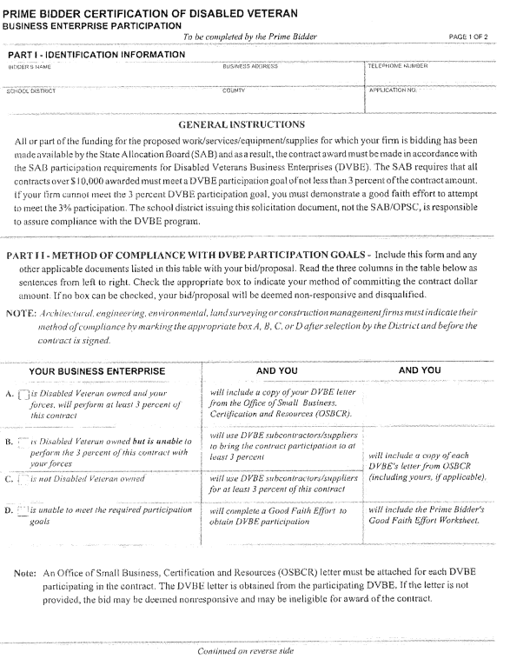
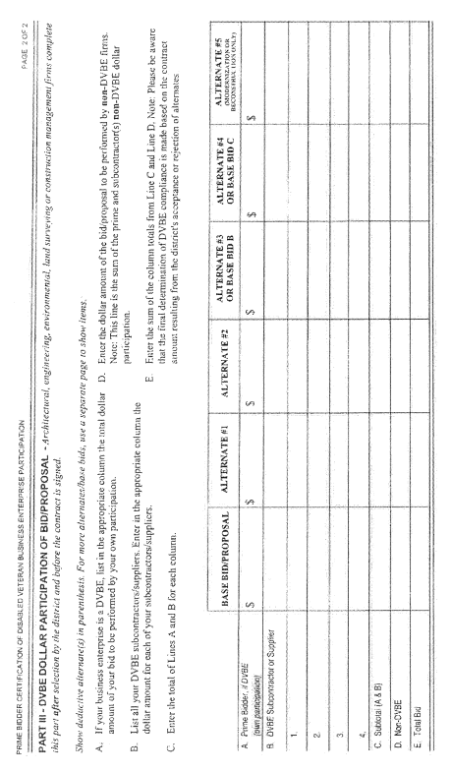

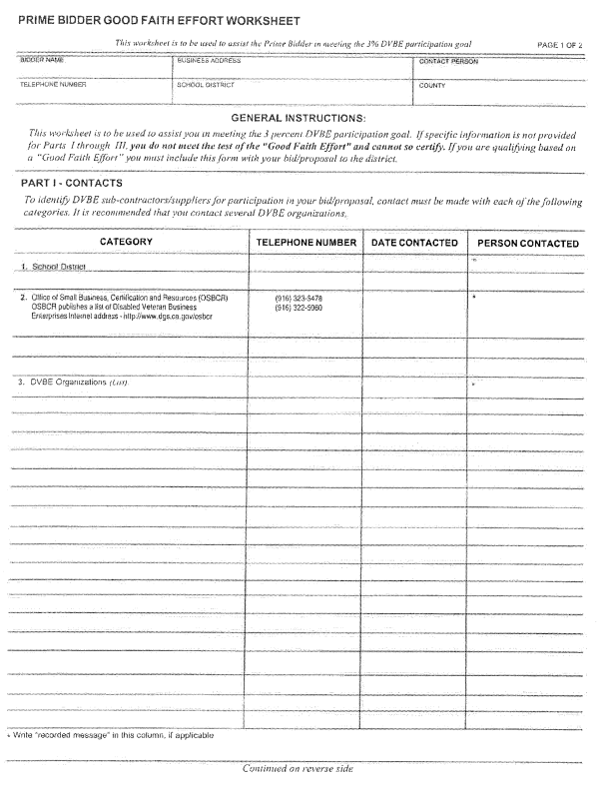
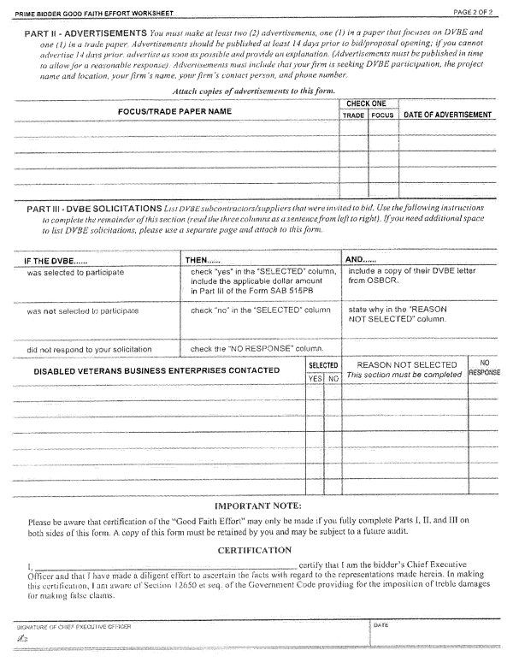

GUARANTEE FORM- to be submitted upon completion and acceptance of job prior to last payment

SAMPLE FORM

( Letterhead of the Contractor responsible for work to be guaranteed)

GUARANTEE FOR

________________________________________________________________
(Work)

We hereby guarantee that the workmanship and materials that [we installed / work performed] at:

the _____________________________________________________________

________________________________________________________________

have been in accordance with Drawings and Specifications, and that the work as installed will fulfill the requirements of the guarantee included in the Specifications. We agree to repair or replace any or all work, together with any other adjacent work that we may displace in so doing, that may prove to be defective in its workmanship or materials within a period of five (5) years and a manufacturer’s warranty for labor and materials for five (5) years from date of acceptance of the above-named structures by the Trustees of the Nevada Joint Union High School District, ordinary wear and tear and unusual abuse or neglect excepted, at no cost whatsoever to the Owner.

In the event of our failure to comply with the above-mentioned conditions within fifteen (15) days after being notified in writing by the Clerk of the Trustees of the Nevada Joint Union High School District, we collectively or separately do hereby authorize said Clerk of the Trustees to proceed to have said defects repaired and made good at our expense and we will honor and pay the costs and charges therefore upon demand.

_____________________________ ________________________________
Signed Date
_____________________________ ________________________________
Name Title
_____________________________ ________________________________
Contractor License No.
________________________________________________________________
Address
_____________________________ ________________________________
Countersigned Date
_____________________________ ________________________________
Name Title

Specifications:

DESCRIPTION OF WORK

The work to be done consists of providing all labor, supervision, materials, and equipment needed to repair the J Wing Stairway Repairs at Nevada Union High School
- Due to the start of school the Job needs to be completed by August 11, 2021
- If completion date is not attained for any reason the contractor may be required to work outside of educational hours without additional compensation.
- Contractor is responsible for complete disposal of all waste.
- Contractor is responsible for coordinating work, and inspections as required with District IOR/Lab assigned to the project.
- Contractor is responsible for site security and safety including but not limited temporary fences and/or barricades associated with the stairway repairs.
- The contractor is responsible for protecting the site and returning it in the same or better condition than when the project started.
- Utilities- Water and basic 115V 20A power will be provided by the District at no cost for this project.

Quality Assurance:
Work performed under this Section shall conform to the Drawings and Specifications and shall comply with all standards, rules and regulations, laws and ordinances of all authorities having jurisdiction. That which is necessary to make the work comply with the above requirements shall be provided without additional cost.

Attached Drawings and Supporting Documents:

- Drawings

PDFs are available at: https://www.njuhsd.com/Measure-B--/Upcoming-Projects-to-Bid/index.html

